|  |  |  |  |
| --- | --- | --- | --- |
| **Name of Student: NINAD AVINASH PATIL** | | | |
| **Roll No: 33** | | **Lab Practical Number: 4(A)** | |
| **Title of Lab Practical: Design online registration form for the participation of technical event (use HTML Controls, user controls and validation controls).** | | | |
| **DOP: 26/03/2021** | | **DOS: 31/03/2021** | |
| **CO Mapped: CO1** | **PO Mapped: PO3, PO5, PO7,**  **PO12, PSO1, PSO2** | **Faculty Signature:** | **Marks:** |

**Practical No 4(A)**

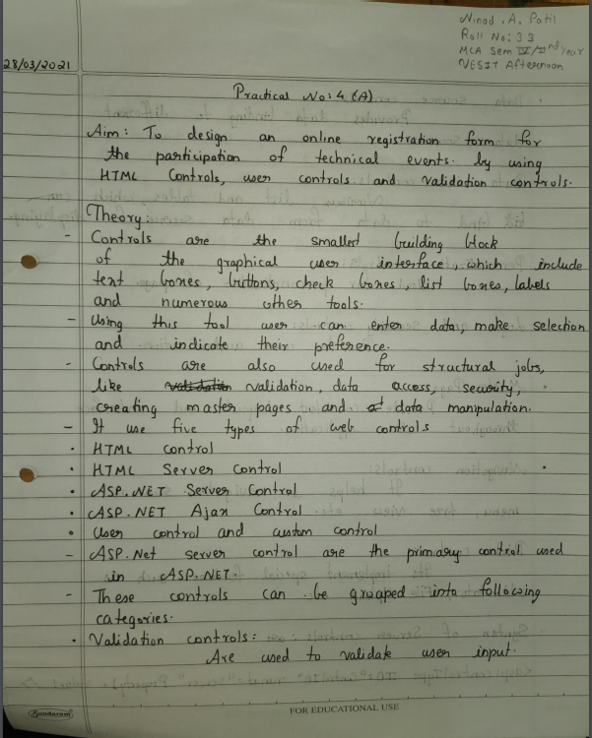

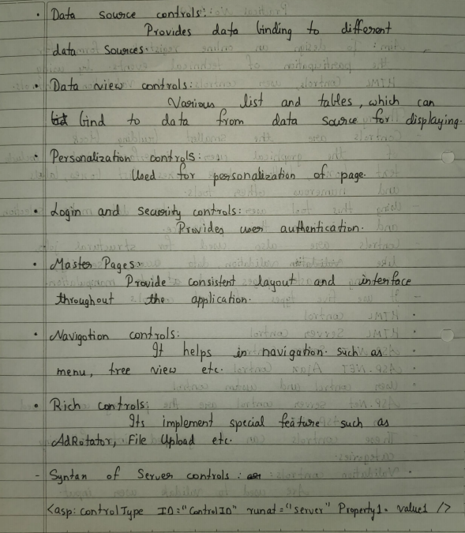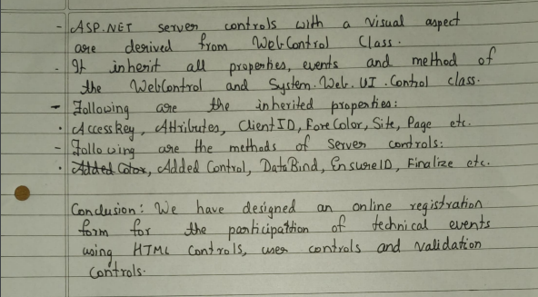

**Code:**

**WebForm1.aspx.cs**

using System;

using System.Collections.Generic;

using System.Linq;

using System.Web;

using System.Web.UI;

using System.Web.UI.WebControls;

namespace P4A

{

public partial class WebForm1 : System.Web.UI.Page

{

protected void Page_Load(object sender, EventArgs e)

{

Label6.Visible = false;

}

protected void Button1_Click(object sender, EventArgs e)

{

if (TextBox1.Value != "" && TextBox2.Value != "" && TextBox3.Text != "" && TextBox4.Text != "" && TextBox5.Text != "")

{

Label6.Text = "Data Submitted Successfully";

Label6.Visible = true;

TextBox1.Value = TextBox2.Value = TextBox3.Text = TextBox4.Text = TextBox5.Text = "";

}

}

}

}

**WebForm1.aspx**

<%@ Page Language="C#" AutoEventWireup="true" CodeBehind="WebForm1.aspx.cs" Inherits="P4A.WebForm1" %>

<!DOCTYPE html PUBLIC "-//W3C//DTD XHTML 1.0 Transitional//EN" "http://www.w3.org/TR/xhtml1/DTD/xhtml1-transitional.dtd">

<html xmlns="http://www.w3.org/1999/xhtml">

<head runat="server">

<title>Technical Event</title>

<script language="javascript" type="text/javascript">

function Reset1_onclick()

{

TextBox1.Value = "";

TextBox2.Value = "";

TextBox3.Text = "";

TextBox4.Text = "";

TextBox5.Text = "";

}

</script>

</head>

<body>

<p>

Online Registration Form</p>

<form id="form2" runat="server">

<div>

<asp:Label ID="Label1" runat="server" Text="First Name :"></asp:Label> &nbsp;

<input id="TextBox1" type="text" runat="server"/> <br /><br />

<asp:Label ID="Label2" runat="server" Text="Last Name :"></asp:Label> &nbsp;

<input id="TextBox2" type="text" runat="server"/> <br /><br />

<asp:Label ID="Label3" runat="server" Text="Mobile No :"></asp:Label> &nbsp;

<asp:TextBox ID="TextBox3" runat="server"></asp:TextBox> &nbsp;

<asp:RegularExpressionValidator ID="RegularExpressionValidator2" runat="server" ControlToValidate="TextBox3" ErrorMessage="Invalid Mobile Number" ValidationExpression="^[789]\d{9}$" ForeColor="Red"></asp:RegularExpressionValidator> &nbsp;&nbsp; <br /><br />

<asp:Label ID="Label4" runat="server" Text="Email Id :"></asp:Label> &nbsp;&nbsp;&nbsp;&nbsp;

<asp:TextBox ID="TextBox4" runat="server"></asp:TextBox> &nbsp;

<asp:RegularExpressionValidator ID="RegularExpressionValidator1" runat="server" ControlToValidate="TextBox4" ErrorMessage="Invalid Email Id" ValidationExpression="\w+([-+.']\w+)*@\w+([-.]\w+)*\.\w+([-.]\w+)*" ForeColor="Red"></asp:RegularExpressionValidator> <br /><br />

<asp:Label ID="Label5" runat="server" Text="Branch :"></asp:Label> &nbsp;&nbsp;&nbsp;&nbsp;&nbsp;&nbsp;

<asp:TextBox ID="TextBox5" runat="server"></asp:TextBox> &nbsp;

<asp:RequiredFieldValidator ID="RequiredFieldValidator1" runat="server" ControlToValidate="TextBox5" ErrorMessage="RequiredFieldValidator" ForeColor="Red"></asp:RequiredFieldValidator> <br /><br />

&nbsp;&nbsp;&nbsp;&nbsp;&nbsp;&nbsp;&nbsp;&nbsp;

<asp:Button ID="Button1" runat="server" onclick="Button1_Click" Text="Submit" />

&nbsp;&nbsp;&nbsp;&nbsp;&nbsp;&nbsp;&nbsp;

<input id="Button2" type="reset" value="Reset" onclick="return Reset1_onclick()" /> <br /><br />

<asp:Label ID="Label6" runat="server" Text="Result here"></asp:Label> </div>

</form>

</body>

</html>

**WebUserControl1.ascx**

<%@ Control Language="C#" AutoEventWireup="true" CodeBehind="WebUserControl1.ascx.cs" Inherits="P4A.WebUserControl1" %>

<h2>Online Registration Form</h2>

**Output:**

